# Different Ways of Importing in Python

Below is the image showing the question from DataCamp:

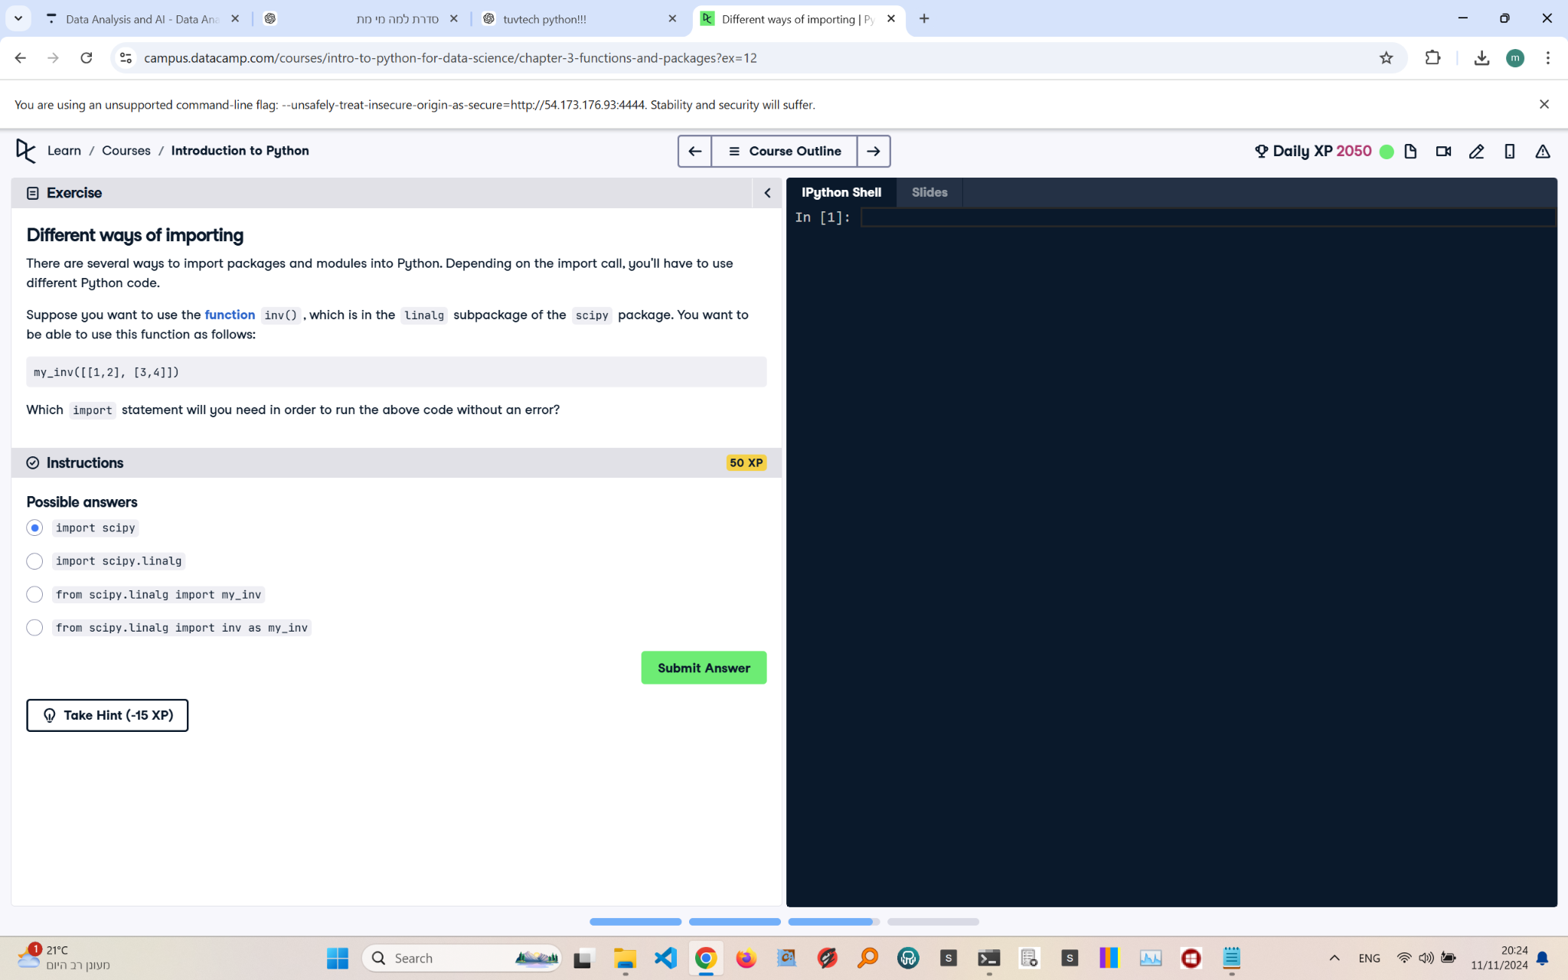

Explanation of the Question:

The question asks about which import statement is needed to use the function inv() from the scipy.linalg subpackage so that the given code can run without errors.

Answer:

from scipy.linalg import inv as my_inv

Explanation of the Answer:

The function inv() belongs to the scipy.linalg subpackage. To use it with the alias my_inv, the correct syntax is 'from scipy.linalg import inv as my_inv'. This allows the function to be referenced as 'my_inv' without having to import the entire scipy or scipy.linalg package.